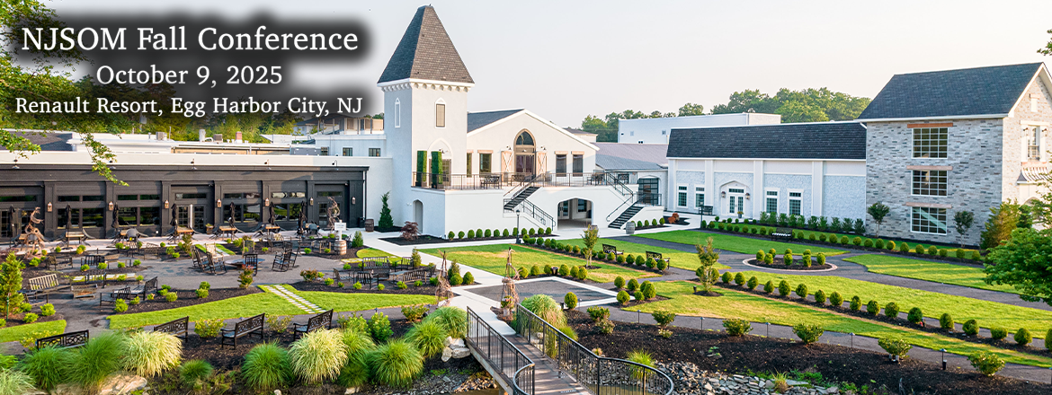

8:00 am | Registration and Breakfast with Exhibitors
8:45 am | "Opening the Barrel: Setting the Tone for a Full-Bodied Discussion"  Linda DeAngelis, President NJSOM
9:00 am | “Ted Okon Uncorked: Federal Updates for Community Oncology”
10:00 am | “Fermenting Frustration or Aged Opportunity? The Payer Landscape in NJ”, Paul Welchans, Principal-onPoint Oncology
10:45 am | Break
11:15 am | “Fine-Tuning the Financial Blend: Principal Care Management in Oncology Billing” ASCO  Allison M. Hirschorn  Director, Coverage and Reimbursement, American Society of Clinical Oncology (ASCO)
12:00 pm | Lunch
12:45 pm | “Barrels & Benchmarks: ASCO’s 2025 Outlook on Community Oncology”  Allison M. Hirschorn  Director, Coverage and Reimbursement, American Society of Clinical Oncology (ASCO)
1:30 pm | “From Policy to Practice: How the IRA Will Reshape Oncology Medication Access”  Understanding the Role of Medicare Fair Pricing (MFP) in Community Oncology, Moderator: Michelle Weiss, Eileen Pang, Astera Oncology, Jonas Congelli, RPh, NCODA, Venus Mignogni RPh, Summit Health
3:00 pm | "Final Pour: Key Takeaways & Closing Thoughts"
Speakers and Topics subject to change

